Instructions for students on Logging in to Management Information System, ABV-IIITM Gwalior

1. Login to <https://mis.iiitm.ac.in/>

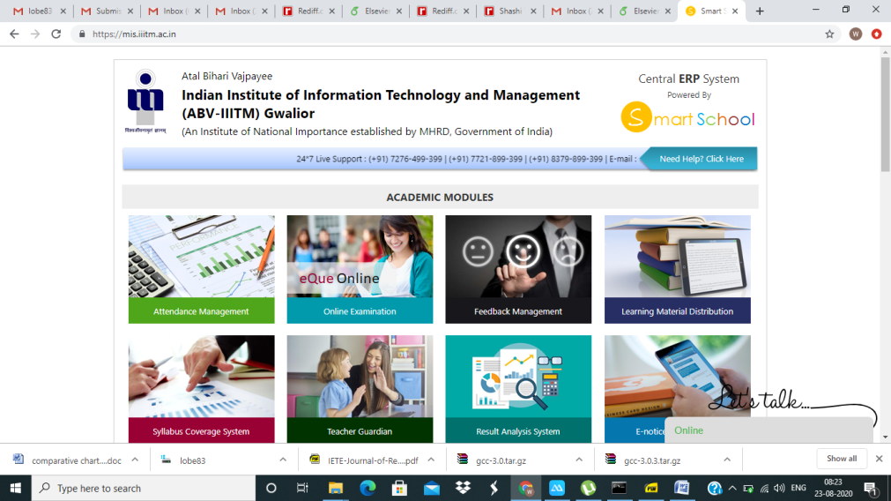

1. Scroll down to the bottom and under STUDENT PORTALS, click “For Students, student portal”.

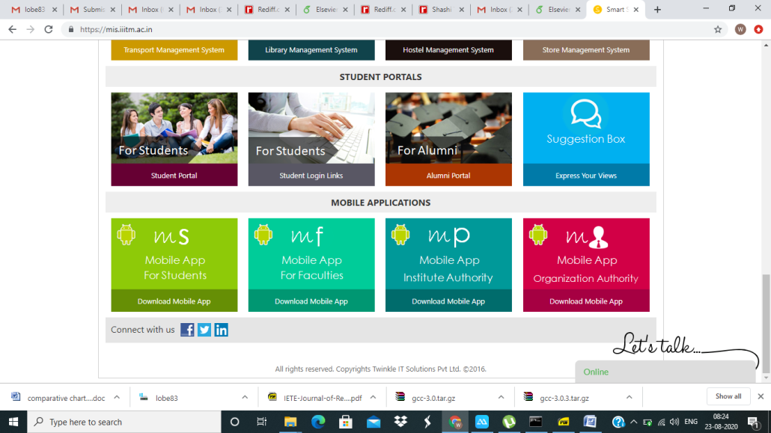

1. Now you enter the following webpage. (<https://mis.iiitm.ac.in/studentinfosys/studentportal/studinfo_studlogin.aspx>)

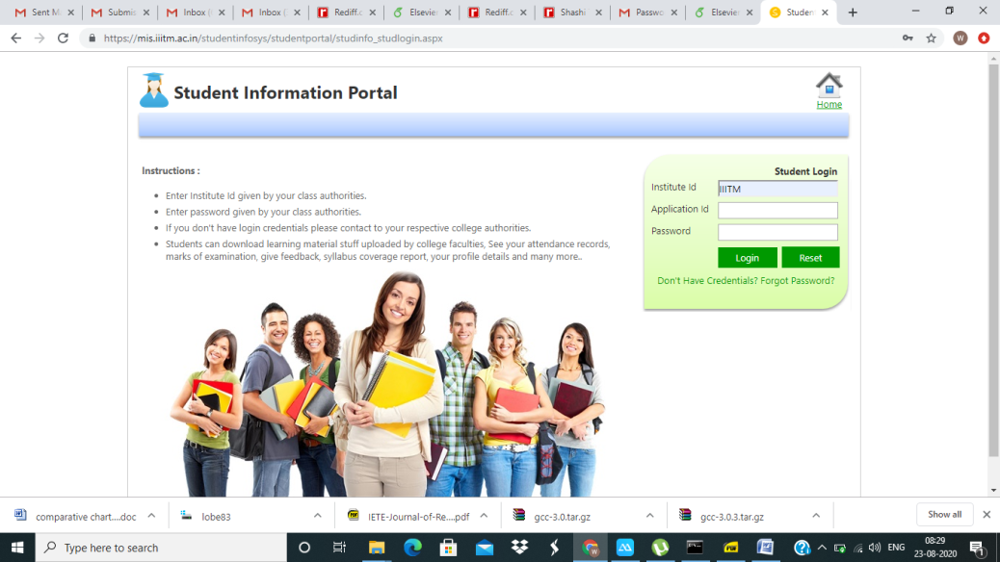

1. Click Forgot Password. **Enter the Institute Id as IIITM, Application id as Roll number, Eg. 2016IPG-000,2019BCS-000, 2019CN-00, 2019MBA-00, 2019IMT-000, 2019IMG-000, 2019PIT-00,2019PAM-000 etc.** and your institute email address as registered email address and click “Get Password” button.

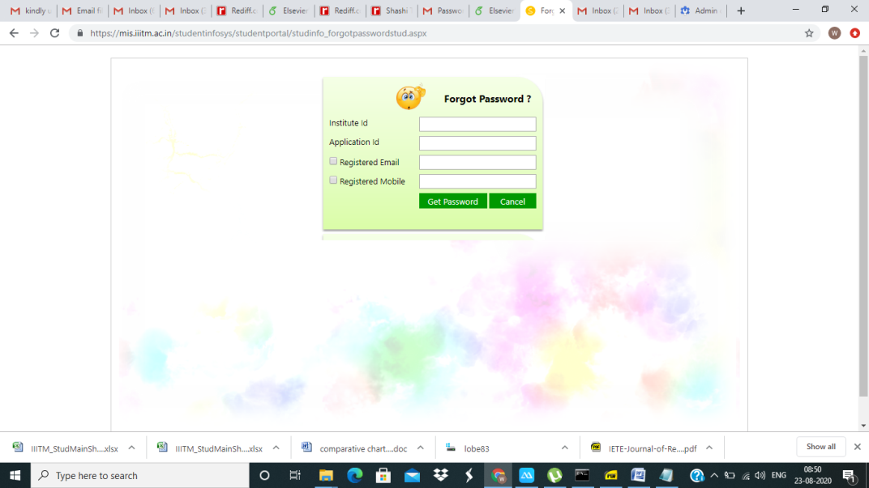

1. You will be receiving the password on your registered email address. Now click the following link to enter the login page <https://mis.iiitm.ac.in/studentinfosys/studentportal/studinfo_studlogin.aspx>. Enter the details such as Institute id, Application id and Password received on your registered email. Now you will be able to login and update your personal details on the portal.



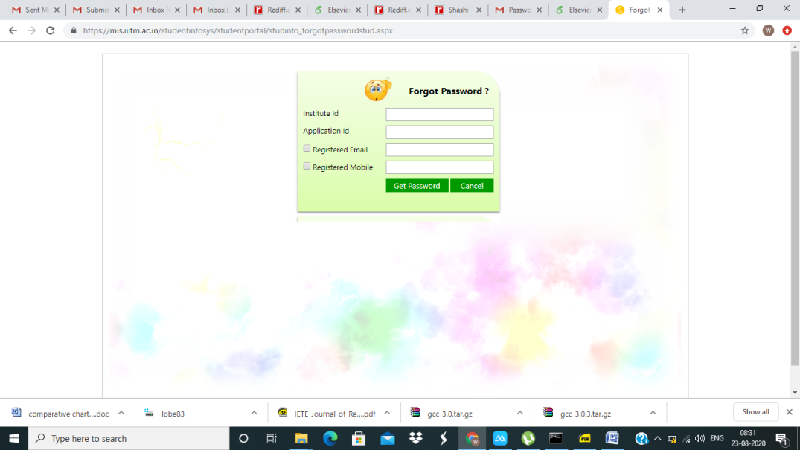

1. Under the portal students can pay fee and register for the courses (core courses already floated will appear by default).

Step 1: Manage profile (fill up the details)

Step 2: Registration form (select academic year and semester, generate registration form then submit and pay fee)